Sponsorship request letter

**Letter Template- Asking your/a company sponsor your Pink Stumps Day Event**

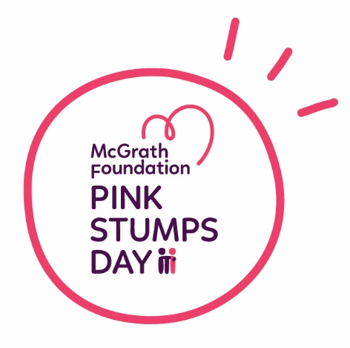

<First name> <Surname>  
<Address>  
<Suburb> <State> <Postcode>

<Date>

Dear < insert company name/contact>,

This year I have decided to raise money for the McGrath Foundation to support the amazing work they do placing Breast Care Nurses in communities across Australia. Breast cancer is the most common cancer affecting women in Australia. Around 19,866 women and 164 men are diagnosed every year and I want to do something to help.

I/we am/are am holding a Pink Stumps Day on <insert date> and brining the magic of the Pink Test back into the community. We’re going to turn our pitch pink, have a fun day of cricket and raise funds to make life a little bit easier for individuals and families experiencing breast cancer.

**(Include some details about your PSD plans – who will be playing cricket, how will you be fundraising)**

My/our goal is to raise $XXX and we/I would love your help!

**I was wondering if you would consider sponsoring the event, so that together we can make a much bigger difference. We would love to feature your logo on our** <posters/raffle tickets/other promotional material> **would love to discuss any other opportunities we may have to promote your amazing support.**

You can check out my/our fundraising page <Insert fundraising page link> or visit pinkstumpsday.com.au for more information on the campaign and the McGrath Foundation.

I would love to meet with you to tell you more about our event.

Thanks so much for your consideration.

Kind regards,

<Insert name/Team Name>